|  |  |
| --- | --- |
|  | OIL AND GAS EXPLORATION AND PRODUCTION – PHASE 1  Andrew McCown, Jeron Russell, Mark Senay,  Nico Krachenfels, Sierra Birade  **Blue Team - 3**  February 08, 2021 |
|  |  |
|  |  |

**Table of Contents**

OVERVIEW 2

Methodology 2

*Data Used* 2

*Monte Carlo Simulation* 2

analysis 2

*Monte Carlo Evaluation* 2

results & recommendations 3

conclusion 4

OIL AND GAS EXPLORATION AND PRODUCTION – PHASE 1

# **OVERVIEW**

This analysis aims to address the drilling risk involved in the basic business model for oil & gas exploration and production. We address this issue for Campagnie Pétrolière Gazière, INC. (hereafter the “Company”), as a preliminary phase in analyzing the entire project's overall risk and potential return. High drilling costs can often ruin a project's profitability, so we decided to drill down into predicting these costs using various simulation techniques. Our final output contains two Monte Carlo simulations - one containing a normal distribution and another containing a kernel density estimation for years 2006-2012. We found that both models provided similar simulation results. The KDE model shows slightly higher costs for the top 10% of outcomes, making it the more conservative option to include in the overall model. For example, at the 95th percentile, the normal distribution cost is $7,131, and the KDE distribution cost is $7,318. Therefore, we recommend using the kernel density model to estimate the welling costs for the year 2021.

# **Methodology**

### *Data Used*

The data of interest provided to the team by the Company needed to complete simulation of costs for 2021 includes estimated drilling costs for crude oil, natural gas, and dry wells. The data available is from 1960-2007 and includes the arithmetic annual change on the costs mentioned above. Since the industry has had substantial changes from 1960-2007 and 2007 was an outlier year, the team will only be using data from 1990-2006.

### *Monte Carlo Simulation*

Simulations provide an effective way to analyze many possible outcomes when what an input variable might be is uncertain. For instance, nobody is certain what the annual change in drilling costs (input variable) will be in the future. Simulations allow distributions of the annual change in drilling costs to be used instead of the exact annual change. The exact annual change is no longer needed as long as there is now an approximated distribution of those changes. Using distribution allows the team to get a clearer picture of the probability that specific outcomes will occur. Our team ran two simulations, one which follows the assumption of a normal distribution of annual change in cost for years 2006-2012 and one which uses the data from 1990-2006 to estimate a distribution using kernel density estimation (KDE). Both simulations also use a triangle distribution based on the average, maximum, and minimum estimates provided by the Company for the years 2012-2020.

# **analysis**

### *Monte Carlo Evaluation*

For the simulations, the starting cost that we used is the average of the well costs for 2006, which was $2,279.8. For the first simulation, we assumed the annual change in cost for the years 2006 to 2012 followed a normal distribution with a mean of .13 and a standard deviation of .18. This mean and standard deviation comes from the distribution of annual changes in cost from 1990 to 2006. To make sure this assumption was valid, we used a QQ plot to check if the annual change in cost from 1990-2006 followed a normal distribution. Figure 1 shows the QQ plot, and because the points mostly fall along the blue line, we concluded that the annual change in cost from 1990-2006 follows a normal distribution.

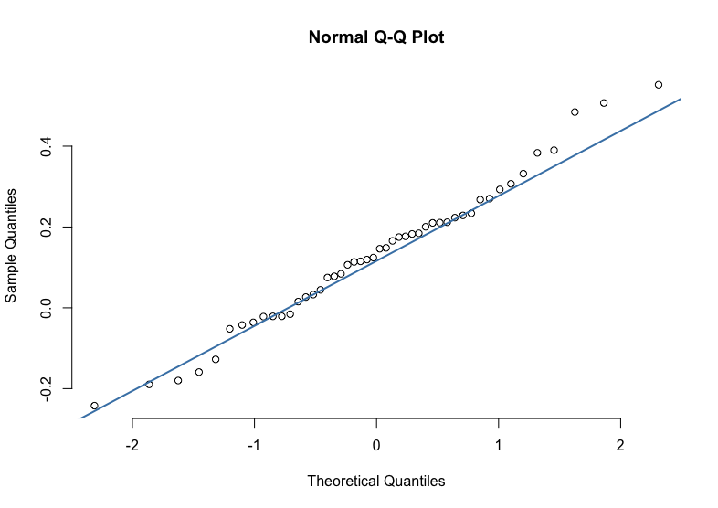

Figure 1: QQ Plot for Annual Changes in Cost Between 1990-2006

From 2012 to 2015 the annual change in costs was decreasing, and we assumed a triangle distribution with a mean annual change in costs of -9.17%, a minimum annual change in costs of -7%, and a maximum annual change in costs of -22%. Then for the years 2015 to 2020, the annual change in costs increased, and we assumed a triangle distribution with a mean annual change in costs of 5%, a minimum annual change in costs of 2%, and a maximum annual change in costs of 6%. Additionally, 2021 was forecasted using the same distribution as 2015 to 2020.

For the second simulation, instead of using a normal distribution to estimate the annual change in costs from 2006-2012, a kernel density estimate was calculated for the annual change in cost for the years 1990-2006 and then used to simulate the annual change in cost for 2006-2012. The years 2012-2020 were simulated using the same distributions used with the first simulation, and 2021 was forecasted using the distribution from 2015-2020.

# **results & recommendations**

After generating the normal distribution simulation and the KDE simulation, our team created two histograms to compare the possible costs using both methods. These histograms (Figure 2 and Figure 3) can be seen below:

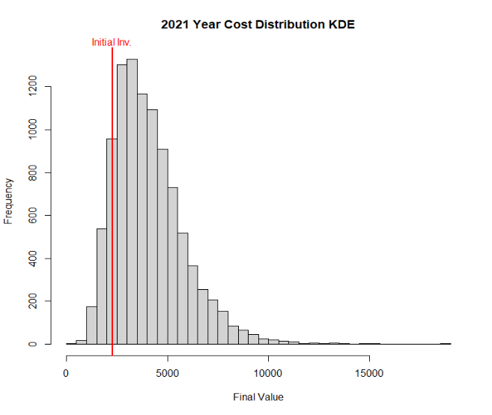

Figure 2: Potential Cost of 2021 Drilling (Normal)

Figure 3: Potential Cost of 2021 Drilling (Kernel)

As seen in figures 2 and 3 the kernel density estimation (KDE) simulation closely mirrors the frequencies shown in the normal distribution simulation. The normal distribution shows a longer tail on the higher end of cost projections, but the KDE looks to have more extreme observations in terms of higher costs. To compare the two simulations in more detail, our team generated a quantile plot (Figure 4), as seen below.

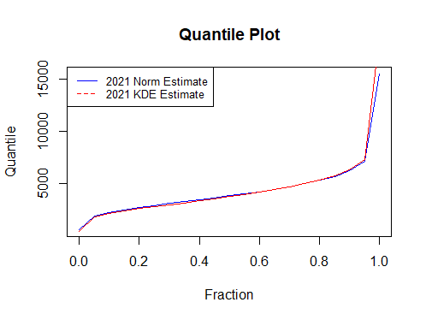

Figure 4: 2021 Drilling Cost Quantile Plot Comparison (Normal, KDE)

The Quantile Plot (Figure 4 above) gives us a closer look at the two simulations’ projected costs. The Kernel Density (KDE) curve in red has a steeper incline for the highest 10% of outcomes, meaning that using the KDE will give us higher possible cost projections than using a normal distribution. Knowing this, our team recommends using the KDE if the Company is interested in planning for the highest possible cost scenario.

# **conclusion**

Our team created two simulation scenarios for the historical costs of drilling: one using a normal distribution and a kernel density estimation (KDE). Upon reviewing the results of the two simulations, similar cost projections were revealed by each. With this in mind, we recommend using the KDE estimation to budget for the potential higher end of costs. For the next steps in the analysis, our team recommends utilizing this cost information against potential gains in drilling each different type of well to construct a business plan. We’ve enjoyed working on this project and look forward to working with the Company to evaluate the possible outcomes of their oil & gas venture.